COURSE: Extracurricular Classes |  | CLB LEVEL: 4 | Lesson #19 | DURATION: 80 min
TOPIC/THEME: The world around us (Conditionals) |  |  | LESSON FOCUS: Vocabulary, Grammar
AIMS
- Understand the correct usage of words connected with environmental issues and phrasal verbs.
- Understand the correct grammar to talk about the unreal past and past wishes
VOCABULARY
- Words connected with environmental issues
STAGE | PROCEDURE |  |  | TIMING
Lead in | Draw a table on the board. Students work in pairs and complete the table.  Ask students to brainstorm vocabulary related to the environment. Write NATURE AND THE ENVIRONMENT in the center of the board, with circles around it with these subheadings: Words related to animals, Environmental problems, Environmental solutions, Nature. Write all students’ suggestions on the board, in the appropriate circles.  - Elicit answers in open class. |  |  | 10 min.
Vocabulary | - Students work individually and make phrases.  - Students complete the exercises #1, #2 and #3 (Handout 1)  - Check the answers after each exercise.  - Students work in pairs and answer the questions.  1. Look at the photos. What are these things? What are they used for? How do they help us?  2. What different kinds of renewable energy can you think of?  - Elicit answers from students.  - Ask learners to complete the exercises using multiple-matching task. (Handout #2)  - Check answers as a class. |  |  | 40 min.
Grammar | Explain the form of Unreal Past and Past wishes. You can use the “Remember” box.  Structures:  Was/ were didn’t + v V + ed (v3)  Ask learners to complete the sentences using the verbs. (Handout #3) |  |  | 10 min.
Controlled Practice | Practice exercises.  Students do the exercises to practice the Past wishes and Unreal past. (Handout #4)  - Check the answers after each exercise. |  |  | 20 min.
Homework | As you assign.
SOURCES OF MATERIALS: (What course books, listening materials, texts, internet sites etc. are you going to use?)
- Macmillan Optimise, B2 Students book, Unit 8 page 83-85
- Handouts #1, #2, #3
- Photos
- Answer key

Lead-in
Complete the table and share what you wrote.
 | What’s going wrong? | What are the solutions?
Oceans
Forests
Deserts
Animals
Weather

Handout #1
Ex.1
Write a word from the box in each gap to make phrases.
change | development | effect | energy footprint | layer | toxic | warming

1. global ___________
2. climate _____________
3. greenhouse ___________
4. waste ______________
5. carbon _____________
6. renewable ______________
7. sustainable _____________
8. ozone ______________

Ex.2
Write a phrase from Exercise 1 in each gap. There may be more than one correct answer.
1. To measure, ________________ you need to look at weather patterns over many years.
2. A person’s ________________ is a measure of the amount of carbon dioxide that is produced by their actions and its effect on the environment.
3. We need ________________ so that our economy can grow without damaging the environment.
4. One of the harmful products produced by industrial processes is_______________.
5. Some countries may face serious problems if ________________ is more than 2˚C.
6. Wind power and wave power are excellent sources of ___________________.
7. The________________ in the atmosphere protects us from dangerous ultraviolet light.
8. The _______________ is when the warmth from the sun is trapped in the

Ex.3
Write a phrasal verb from the box in the correct form to replace the words in brackets in each sentence.
call for | chop down | clean up die out | do away with | run out throw away | wipe out

1. Some animal species __________ (became extinct) due to human activities.
2. People _____________ (are demanding) urgent action on climate change.
3. Will we just keep using oil until it all ______________ (finishes)?
4. We all have a responsibility to help _____________ (tidy) our beaches.
5. If we’re not careful, our actions are going to ______________ (completely destroy) the wild elephant.
6. I think we should ___________ (abolish) cars that produce lots of pollution in city centres to protect the environment.
7. When we __________ (destroy) trees, we remove the natural habitat of a number of species.
8. Don’t just ____________ (put in the rubbish) your old bottles. Recycle them!
Handout #2
In pairs or as a group, ask and answer the questions.
1. Look at the photos. What are these things? What are they used for? How do they help us?
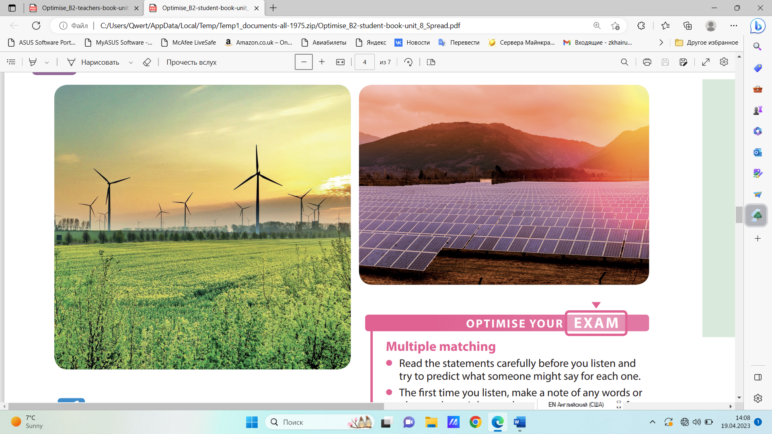
2. What different kinds of renewable energy can you think of?

Ex.1
You will hear five extracts about different projects. Choose from A−H what each speaker says about their project. There are three extra letters you do not need.
A) I enjoyed seeing my ideas in practice.
B) I was happy I did something I found difficult.
C) I was worried we might not make a difference.
D) I shared the concerns of local people. E I discovered I could do more than I thought.
F) I had to show that I knew a lot about energy.
G) I was thankful for the way I was treated.
H) I thought people needed to be educated.
Ex.2
Look at Exercise 4 and read the statements A−H. Match the statements to sentences 1–4.
1 ‘The people there were really friendly and looked after me. I was grateful for that.’
Statement _______________
2 ‘People in the area were worried about the effects and so was I.’
Statement _______________
3 ‘They were looking for experts on energy, and they gave us a test to see what we knew.’
Statement _______________
4 ‘People didn’t seem to know very much about the problem so we need to tell them.’
Statement _______________
Ex.3
Look at the four statements in Exercise 4 you didn’t use in Exercise 2. For each one, predict what the speaker might say. Use your own words.
1 Statement ___
__________________________________
2 Statement ___
__________________________________
3 Statement ___
__________________________________
4 Statement ___
__________________________________

Handout #3
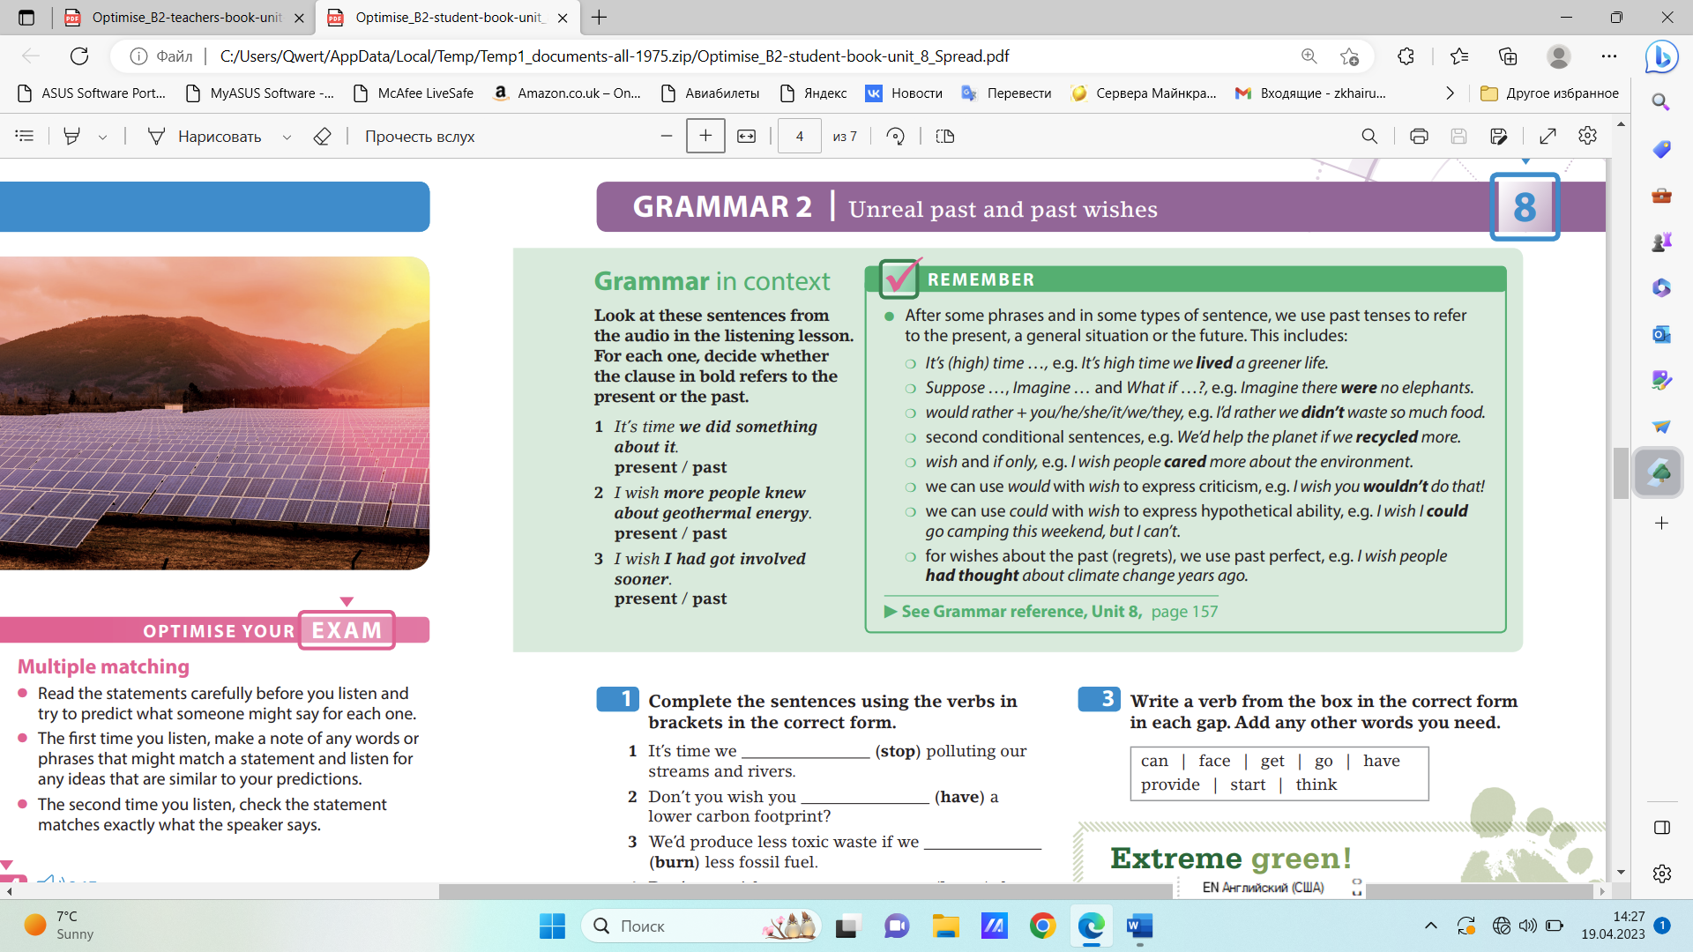

Complete the sentences using the verbs in brackets in the correct form.
1. It’s time we (stop) polluting our streams and rivers.
2. Don’t you wish you (have) a lower carbon footprint?
3. We’d produce less toxic waste if we (burn) less fossil fuel.
4. Don’t you wish you (know) the benefits of living a green life years ago?
5. If only there (be) some way of reducing the effects of global warming.
6. Suppose you (try) to live a lowcarbon life. Would you enjoy it?

Handout #4 (Practice)
Ex.1
Rewrite the sentences in different ways using the words given.
1. Please don’t throw your litter on the ground. RATHER
2. I shouldn’t have bought such a large motorbike. WISH
3. We should manufacture more electric cars in order to help the environment. HIGH
4. I want to wave a magic wand and solve climate change, but I can’t. COULD
5. People should realise that we have to use more renewable energy. TIME
6. Do you want people to take the threat to the environment more seriously? WOULD
Ex.2
Write a verb from the box in the correct form in each gap. Add any other words you need.
can | face | get | go | have provide | start | think

Extreme green! What if your family (1) _____________ rid of the car, the air-conditioning unit, the tumble dryer, the fridge and almost everything else that uses energy in the home? Suppose you never (2) ______________ on holiday or you (3) ________________ to wear extra clothes in bed to keep warm because you had no heating. Those are just a few of the things that people who live an extreme green life have done to try to keep their carbon footprint as low as possible, and many of them wish they (4) ________________ earlier. Of course, we all wish we (5) _________________ use less energy, and for many of us it’s high time we (6) _________________ of ways to cut down on our energy use. However, few of us are prepared to deliberately keep our house cold in the winter and grow all our own food. We’d much rather supermarkets (7) _______________ us with everything we need, but the food in shops has often travelled a long way to get there. These ‘food miles’ increase your carbon footprint. Perhaps it’s about time we (8) _______________ up to reality and thought more carefully about the effect our everyday actions have on the environment.

Answer key
Handout #1 (ex.1)
1. global warming
2. climate change
3. greenhouse effect
4. toxic waste
5. carbon footprint
6. renewable energy
7. sustainable development
8. ozone layer
Ex. 2
1. climate change / global warming
2. carbon footprint
3. sustainable development
4. toxic waste
5. global warming
6. renewable energy
7. ozone layer
8. greenhouse effect
Ex.3
1. Some animal species died out due to human activities.
2. People are calling for urgent action on climate change.
3. Will we just keep using oil until it all runs out?
4. We all have a responsibility to help clean up our beaches.
5. If we’re not careful, our actions are going to wipe out the wild elephant.
6. I think we should do away with cars that produce lots of pollution in city centres to protect the environment.
7. When we chop down trees, we remove the natural habitat of a number of species.
8. Don’t just throw away your old bottles. Recycle them!
Handout #2
Ex.1
1. G (The family I stayed with … really looked after me well and I was so grateful …)
2. A (It was really satisfying when the school governors agreed and the project went ahead.)
3. E (I learnt a lot about myself and what I’m capable of)
4. B (but I pushed myself and was really glad that I met the challenge.)
5. H (I wish more people knew about geothermal energy. If they were better informed … local people were largely ignorant …)
Ex.2
1. G
2. D
3. F
4. H
Ex.3
1. Statement A (‘I loved it when I saw people following my suggestions.’)
2. Statement B (‘It was hard, but I was glad when I managed it.’)
3. Statement C (‘I was concerned that we might not have any effect.’)
4. Statement E (‘I did some things that I didn’t think I was capable of doing.’
Handout #3
1. stopped
2. had
3. burnt
4. had known
5. were/was
6. tried
Handout #4
Ex.1
1. I’d rather you didn’t throw your litter on the ground.
2. I wish I hadn’t bought such a large motorbike.
3. It’s high time we manufactured more electric cars in order to help the environment.
4. If I could wave a magic wand and solve climate change, I would.
5. It’s (high) time people realised that we have to use more renewable energy.
6. Would you rather people took the threat to the environment more seriously?
Ex.2
1. got
2. went
3. had
4. had started
5. could
6. thought
7. provided
8. faced

